**DEPARTMENT OF**

**ELECTRONICS AND COMMUNICATION ENGINEERING**

**College of Engineering and Technology**

**SRM Institute of Science and Technology**

MINI PROJECT REPORT

ODD Semester, 2023-2024

Lab code & Sub Name : 18ECE201J- Python and Scientific Python

Year & Semester : III Year, V semester

Project Title : ATM MACHINE MANAGEMENT SYSTEM

Lab Supervisor **:**  DR R DAYANA

Team Members : ROHAN GARG (RA2111004010007)

KUNAL RAJ (RA2111004010015)

G.ANANTHA NARAYAN (RA2111004010030)

|  |  |  |
| --- | --- | --- |
| **Particulars** | **Max Marks** | **Marks Obtained** |
| **Name: Rohan garg** |
| **Register No : RA2111004010007** |
| Program and Execution | 20 |  |
| Demo verification &viva | 15 |  |
| Project Report | 05 |  |
| **Total** | **40** |  |

Date: **Signature of Course Teacher**

**ATM MACHINE MANAGEMENT SYSTEM**

**OBJECTIVE:**

To design a program for atm machine management.

**ABSTRACT:**

The ATM Machine Management System is the project which is used to access their bank accounts in order to make cash withdrawals. Whenever user want to make withdrawals, they can enter their ATM card and verified PIN, then user select the withdrawal option and enter the withdrawal amounts and it will display the amount to be withdrawn. The user also able to perform one or more transactions. Security is the foundation of good ATM system. This system will provide for secure connections between users and the bank

servers**.**

**INTRODUCTION:**

The ATM is an automatic banking machine which allows the user to complete basic transactions without any help of bank representatives. There are two types of automated teller machine. The basic one allows the customer to only draw cash and receive a report of the account balance. Another one is a more complex machine which accepts the deposit, provides credit card payment facilities and reports account information.

**SOFTWARE REQUIREMENTS:**

Software: Anaconda Navigator & Jupyter, Spyder - Python 3

**CONCEPTS/WORKING PRINCIPLE:**

In Python, we can create an ATM program for representing ATM transection. In the ATM program, the user has to select an option from the options displayed on the screen. The options are related to withdraw the money, deposit the money, check the balance, and exit. To withdraw the money, we simply get the withdrawal amount from the user and remove that amount from the total balance and print the successful message To deposit the money, we simply get the deposit amount from the user, add it to the total balance and print the successful message.

**APPROACH/METHODOLOGY/PROGRAMS/OUTPUT:**

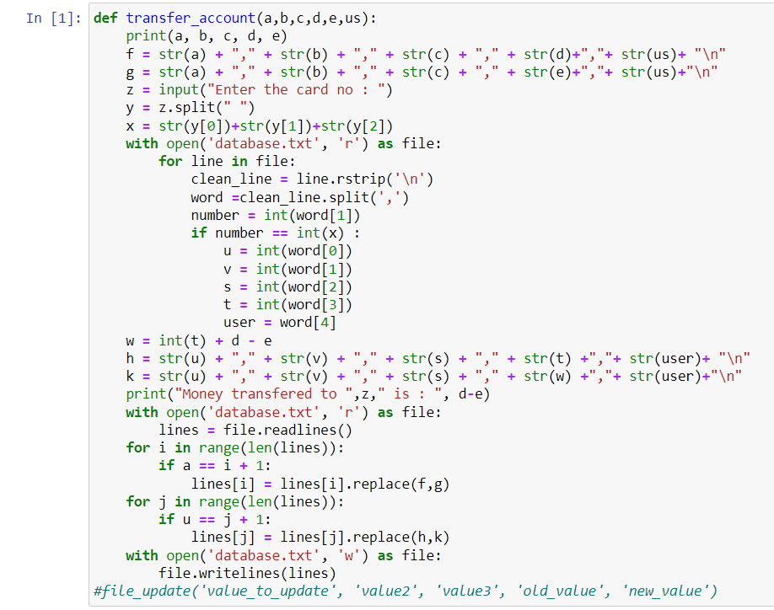

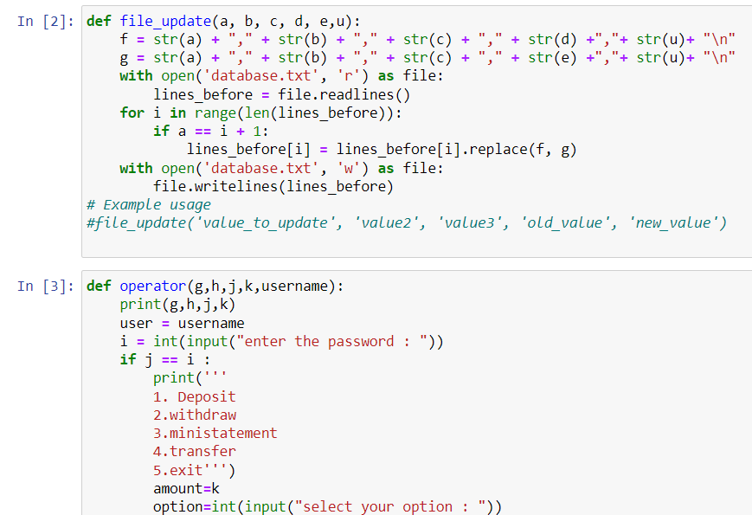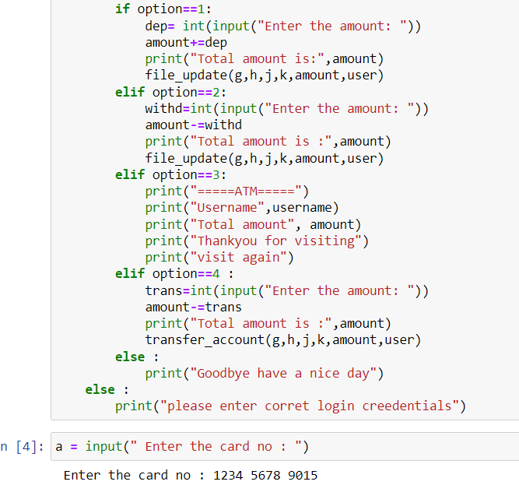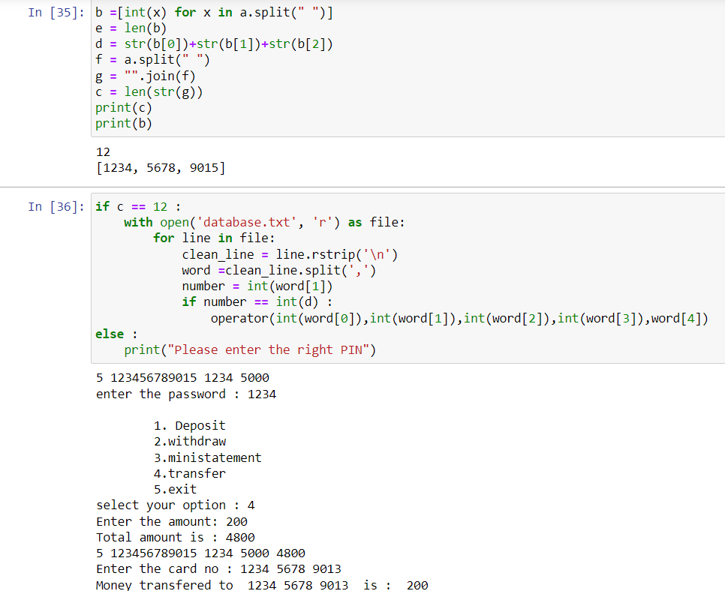

**OUTPUT**

**Database values before deposit**

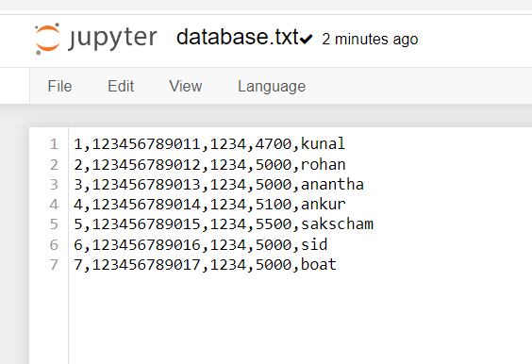

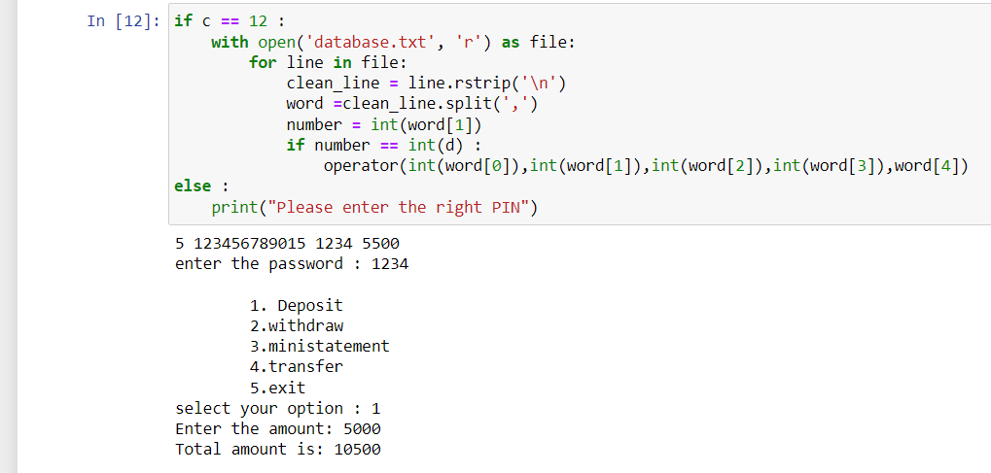

**Data base values after deposit**

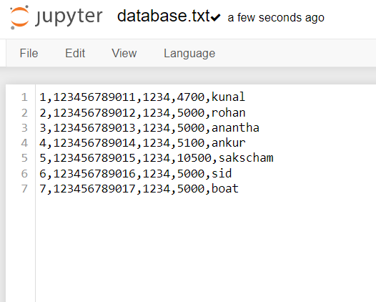

**Now we transfer some amount from one account to another**

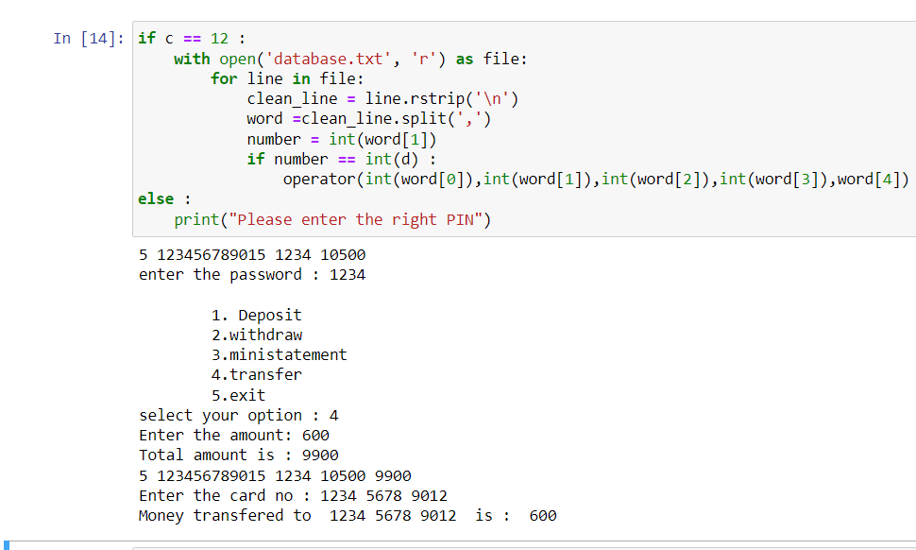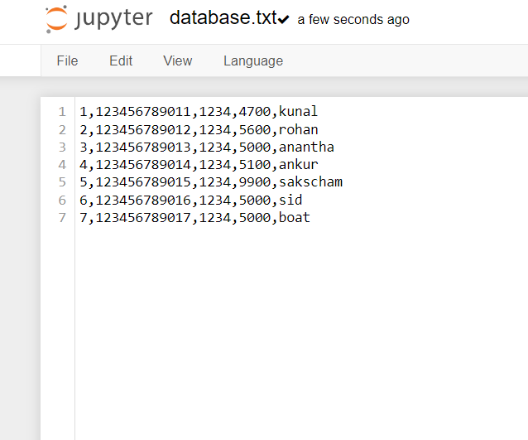

**CONCLUSIONS:**

Hence, a program atm machine management system is designed in Python.

**REFERENCES:**

https://sourcecodeherd.com/atm-program-in-python-with-source-code/

https://code-projects.org/simple-atm-system-in-python-with-source-code/